**BioSIM 11 Start up**



**Jacques Régnière**

**Rémi Saint-Amant**

**Ariane Béchard**

**Ahmed Moutaoufik**

**Gabrielle Bourassa-Tait**

**2020**

**Natural Resources Canada**

**Canadian Forest Service**

**Laurentian Forestry Centre**

**P.O. Box 10380, Stn. Sainte-Foy**

**Quebec, QC Canada, G1V 4C7**

[1 Introduction 3](#_Toc46901507)

[1.1 Main interface 4](#_Toc46901508)

[2.2 Creating a project 6](#_Toc46901509)

[2 Example 1 7](#_Toc46901510)

[Step 1: Defining a group of components 7](#_Toc46901511)

[Step 2: Defining a Weather Generation 7](#_Toc46901512)

[Step 3: Defining Model Execution 12](#_Toc46901513)

[Step 4: Defining an analysis to interpret the results 13](#_Toc46901514)

[Step 5: Adding a component onto another component 15](#_Toc46901515)

[Step 6: Exporting the results 16](#_Toc46901516)

[3 Example 2 18](#_Toc46901517)

[Step 1: Defining a new group of components 18](#_Toc46901518)

[Step 2: Defining a new simulation 18](#_Toc46901519)

[Step 3: Defining an average output analysis 19](#_Toc46901520)

[Step 4: Defining and running an event extraction analysis 19](#_Toc46901521)

[Step 6: Running the checked components 20](#_Toc46901522)

[Step 7: For R user: add automatic execution of R script 21](#_Toc46901523)

[4 Example 3: Mapping 24](#_Toc46901524)

[Step 1: Defining a Weather Execution and Model Execution 24](#_Toc46901525)

[Step 2: Defining a subset analysis 25](#_Toc46901526)

[Step 3: Defining a mapping 25](#_Toc46901527)

[Step 4: Run All 26](#_Toc46901528)

[Step 5: Viewing the R² cross-validation results 26](#_Toc46901529)

[Step 6: Viewing the maps 27](#_Toc46901530)

[5 Example 4: Update current daily database 28](#_Toc46901531)

[Step 1: Adding a new Subgroup of components 28](#_Toc46901532)

[Step 2: Defining an Update weather data 28](#_Toc46901533)

[Step 3: Defining a weather generation and model execution 29](#_Toc46901534)

[Step 4: Defining an output analysis 30](#_Toc46901535)

[Step 5: Defining a function Analysis 30](#_Toc46901536)

[Step 6: Defining a mapping 31](#_Toc46901537)

[Step 7: Run and Viewing the maps 31](#_Toc46901538)

[Step 8: Adding event (date) mapping 31](#_Toc46901539)

# 1 Introduction

This tutorial’s objectives are (1) to give the BioSIM user a general overview of the software’s main capabilities, and (2) to illustrate the sequence of actions normally involved in using the software.

BioSIM can be download here:

<ftp://ftp.cfl.scf.rncan.gc.ca/regniere/software/BioSIM/BioSIM11_x_x.zip>

If you whish to skip the initial setup described below and simply understand the examples, the entire demo containing the same fictional project can be found here:

<ftp://ftp.cfl.scf.rncan.gc.ca/regniere/software/BioSIM/DemoBioSIM.zip>

Because the average user does not have writing privileges in the \Program Files\ directory, it is strongly recommended to unzip the BioSIM application under a working directory such as C:\NRCan\.

The DemoBioSIM project is provided with a North American Normals database (Canada-USA 1981-2010). However, several other Normals databases (Europe and the World) are available at:

<ftp://ftp.cfl.scf.rncan.gc.ca/regniere/Data11/Weather/Normals/>.

Databases taking into account climatic change predictions are available at:

<ftp://ftp.cfl.scf.rncan.gc.ca/regniere/Data11/Weather/Normals/ClimaticChange>.

Several Daily databases are available at:

<ftp://ftp.cfl.scf.rncan.gc.ca/regniere/Data11/Weather/Daily/>.

Several Hourly database are available at:

[ftp://ftp.cfl.scf.rncan.gc.ca/regniere/Data11/Weather/Hourly/](ftp://ftp.cfl.scf.rncan.gc.ca/regniere/Data/Weather/Daily/).

NOTE: A Canadian and USA Daily and Hourly database containing weather data for the last 2 years is also available and is updated frequently (usually daily).

## 1.1 Main interface

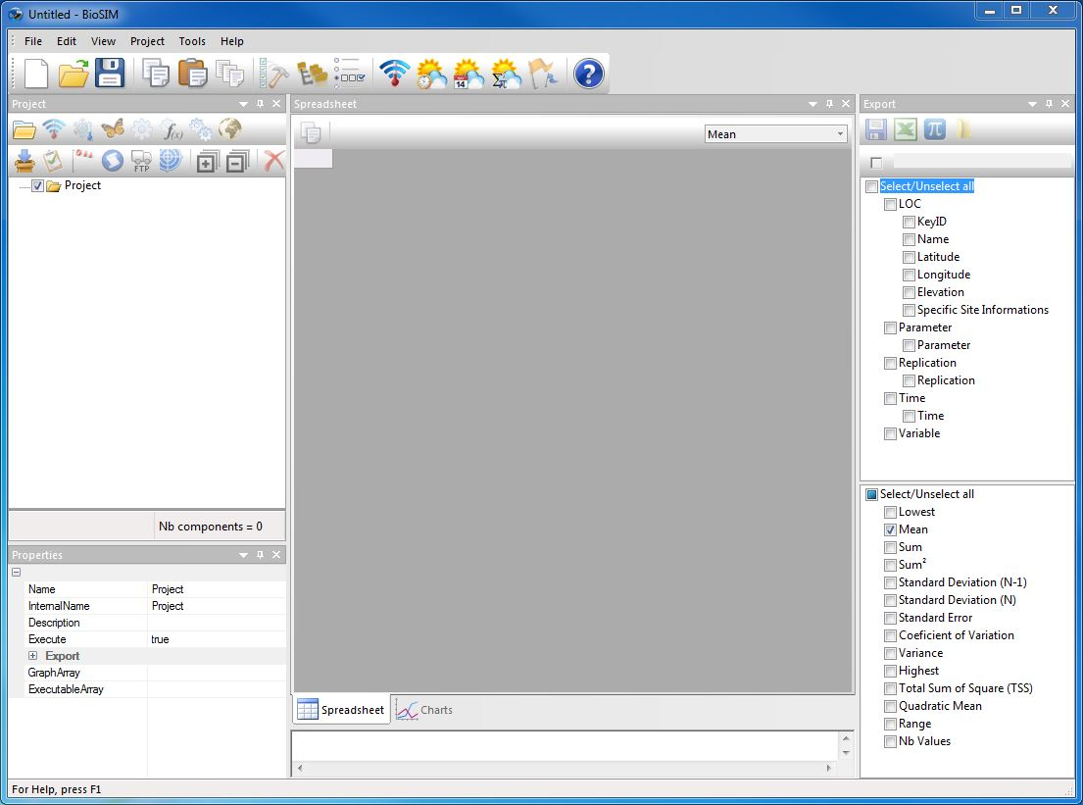

**Main window**:

Show the results of the selected component.

**Export window**: Send the results of the current component outside of BioSIM. Select the variables and the statistics to be exported.

**Properties window**:

Show the properties of the current component.

**Execute Message Log window**:

Show notifications concerning the last execution.

**Project window**: Add a new component to the project.

The main window of BioSIM is composed of the Execute Message Log. There are 4 secondary windows docked to the main window: Project, Properties, Spreadsheet and Export that can be moved around and closed at will.

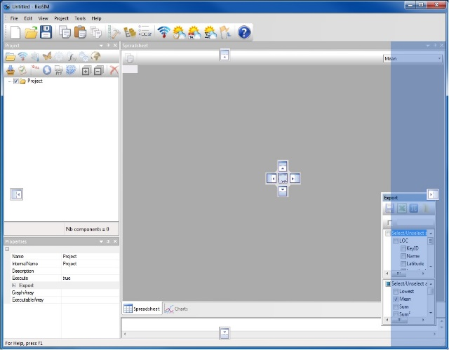

The 4 secondary windows can be configured by the user. When a secondary window is moved/dragged using the mouse, two pictograms appear on screen; one surrounding the main window, and one in either the main window (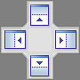), or in whichever secondary window (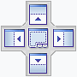) you are attempting to drag the first secondary window. These pictograms will highlight the area where the secondary window currently being dragged will be docked once it is released. The secondary windows can also be left free (undocked).

All secondary windows can be grouped together in a single window docked to the main window and become accessible as tabs in this window.

To reopen a secondary window once it has been closed, select [View] and then [Toolbars and Docking Windows] from the menu bar.

The Project window lists all the components of a project, it is through this window that you can add, remove and edit project components. All tabs and windows in BioSIM are linked to the component selected in the Project window. A project is composed of a set of components that can be grouped together in sub-sets. When a component is selected in the Project window, all other tabs and windows will be updated with the information concerning this component.

When a component is executed, using the Execute Checked  button on the main window’s toolbar, the *Data* tab in the main window will show the numerical results of the component in question while the *Graph* tab will allow you to create and then display graphs of these same results.

The Properties window shows the internal parameters of the component. The Execute Message Log window shows the last execution notifications. The Export window shows all the variables that where selected for export (regardless of their dimension).

The following is a list of the various components that can be added to a project by clicking one of the following buttons on the first row of the Project window’s toolbar.

* **Group**: Used to easily group components into sub-projects.

 **Weather Updater:** Used to download weather data and create BioSIM weather database.

** Weather Generation:** Creates weather for locations. Used togenerate weather from observations (daily/ hourly) or stochastic disaggregation or a mix of both.

** Model Execution**: Executes models to transform weather into model-specific output (models are in fact external dll’s or exe’s). For example, a spruce budworm model transforms weather into spruce budworm life-stage development.

** Analysis:** Based on the output of another component (weather generation, model execution, analysis, etc.), this creates a subset of the results of this component and/or extracts information such as time transformations, events or statistics.

** Function Analysis**: Executes row calculations based on a formula. Can be used to transform time reference into Julian day.

** Merge**: Merges several components of a group to create a single component.

** Mapping**: Adds a mapping component to a parent component (weather generation, model execution, analysis, etc.). Performs spatial interpolations to create maps from data points.

 **Import File**: Imports data from an external file.

 **Weather Input Analysis**: Can only be performed on a weather generation, is used to examine weather input.

 **Dispersal**: Used to simulate the dispersal of an insect in the wind. Only spruce budworm is available.

 **Script**: Used to call an external application (like R) with a file in the output directory.

 **Copy Export**: Used to copy export file to another directory or an ftp site.

 **Model Calibration**: Allows using the parameters of a model using «Simulated Annealing».

An unlimited number of child components can be added to parent components allowing you to create chains of varying length and composition within each project. However, depending on the nature of the parent component, it is possible that only certain types of child components can be added (for detailed explanations and examples please refer to the manual).

## Creating a project

The first thing you must do in BioSIM is create a project.

To create a new project, click on [File] and then [Save As…] in the menu bar.

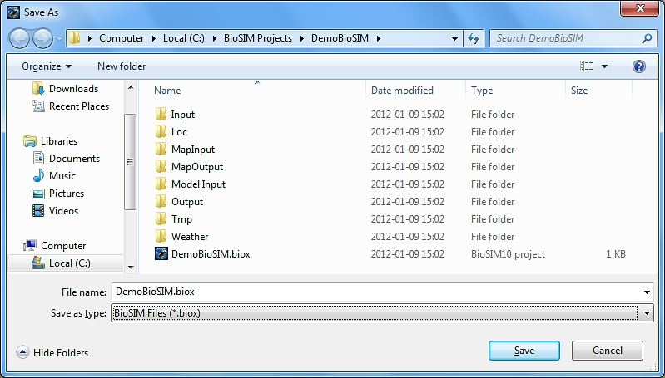

Select a directory in which to save your project. It is strongly recommended to create a new directory when saving a new project, as BioSIM will automatically generate several new sub-directories whenever a new project is created. For example, create a directory with a name such as DemoBioSIM and name the file DemoBioSIM.biox (if you omit the file extension, it will automatically be assigned a .biox extension). All the information related to this tutorial will now be stored in this project directory.

# 2 Example 1

The objective of the first example is (1) to show you how to create a simulation using historical weather data from 2008 to 2010 and (2), to show you how to extract and export some climate variables.

## Step 1: Defining a group of components

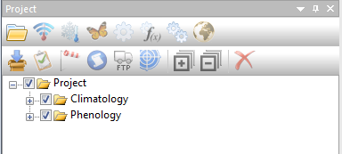 In the Project window, select the “Project” folder icon and then click the Add Group button  on the first row of the Project window’s toolbar, or select [Project] and then [Add Group] from the menu bar. This will add a group to the “Project”.

**1-**To add a component into another, you must first select the parent component.

**2-**Then, click on the add component button that lets you add the appropriate type of child component.

Select the “Group” component you just created, click on it a second time and rename this group Climatology.

## Step 2: Defining a Weather Generation

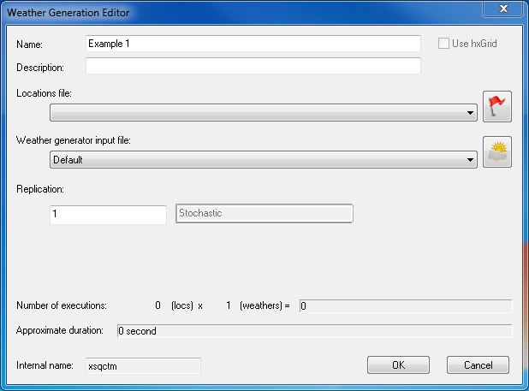Select the “Climatology” group you just created and click the Add Weather Generation button  on the first row of the Project window’s toolbar, or select [Project] and then [Add Weather Generation] from the menu bar.

This will open the Weather Generation Editor dialog with which a new Weather Generation can be defined.

Type Example 1: 2008-2010 in the **Name** field, this name will appear in the Project window.

If you wish, you can type in a description of the simulation being defined in the **Description** field. This description will appear in the Execute Message Log window once the component has been executed.

Then click on  the button. This will open two dialogs; the first dialog is the Location File Manager while the second is the Location List Editor.

In the Location File Manager dialog, click the New button New_button_icon and type in Specific Locations as the name of your new location list. A new file with the name Specific Locations.csv will be created under the \Loc\ sub-directory of the project. This file is in Coma-Separated Values (CSV) format and contains a header line with the following column names: KeyID, Name, Latitude, Longitude and Elevation. For instructions on how to create a location list using Excel, please refer to the manual.

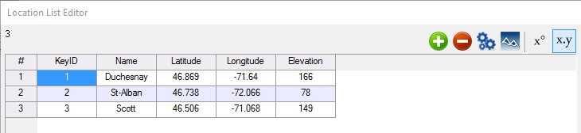In the Location List Editor dialog, click the Add Point button  three times and enter the names, coordinates and characteristics for three locations (for the purposes of this example, copy and paste the relevant information from the lines bellow).

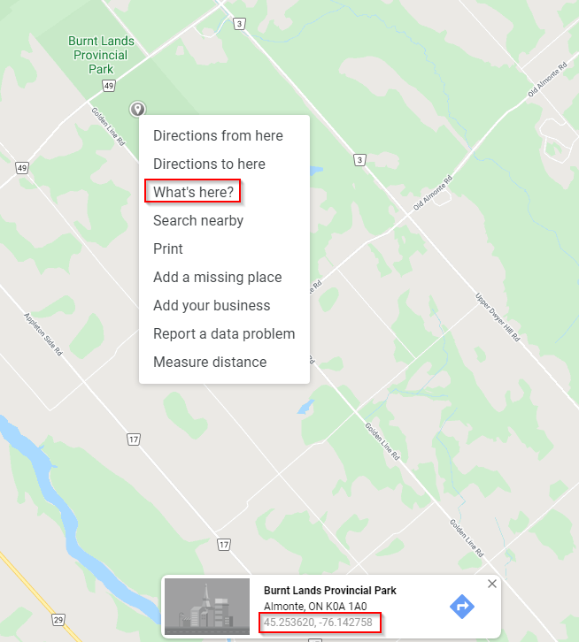

1 Duchesnay 46.869 -71.64 166

2 St-Alban 46.738 -72.066 78

3 Scott 46.506 -71.068 149

Optionally you can also add a point of your own. In the case you don’t know the coordinate of a geolocalisation. You can open Google Maps and choose a location. Right click on the point of interest and select “what’s here?” to get the coordinates.

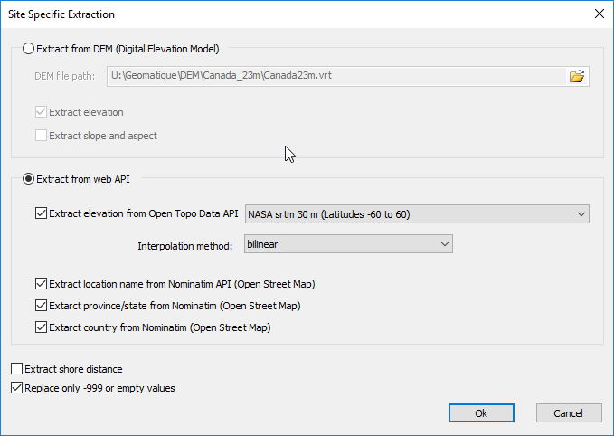Click the Add Point button one more time, and enter the coordinates found for your point of interest. You can extract elevation with the “Extract” button 

Select “Extract from Web API” and then check all four boxes. Next select “NASA srtm 30m (Latitudes -60 to 60)” from the first drop-down menu. Select “bilinear” for the interpolation method. Click OK.

Once you have entered all the information, click OK to save this new location list.

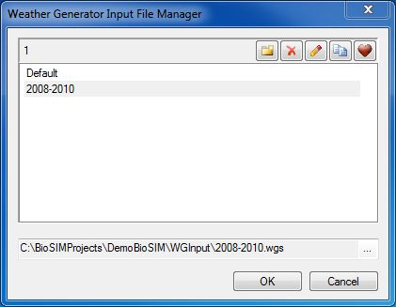Click the Define WG Input button  located at the far right of the **Weather generator** field to define the weather regime assembly parameters. Two dialogs will appear; the first dialog is the Weather Generator Input File Manager while the second is the Weather Generator (WG) Parameters.

In the Weather Generator Input File Manager dialog, click the New button New_button_icon and type in 2008-2010 as the name of the new set of parameter values to be defined. A new file with the name 2008-2010.wgs will be created in the \WGInput\ sub-directory of the project.

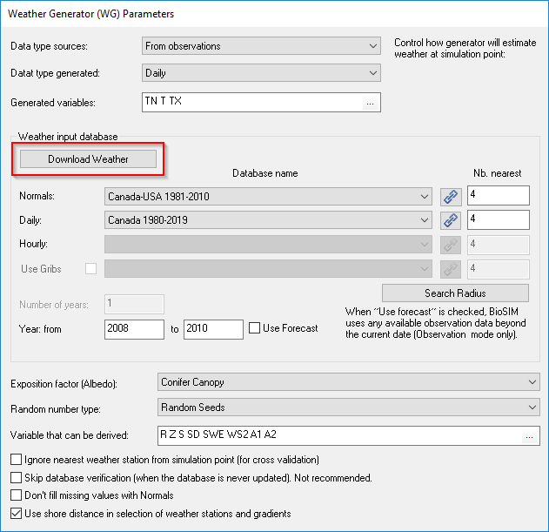This will activate the Weather Generator (WG) Parameters dialog that allows you to modify the weather generator’s parameters. For this example, you will be using real historical data and not stochastic disaggregation data obtained from Normals. Therefore, start by selecting the “Download Weather”.

You will see two drop-down menus, “weather type” and “Select FTP File”. Leave the weather type as Daily, and then, select “Canada\_1980-2019.zip” from the FTP file drop-down list.

NOTE: This database will be replaced by another one in the future.

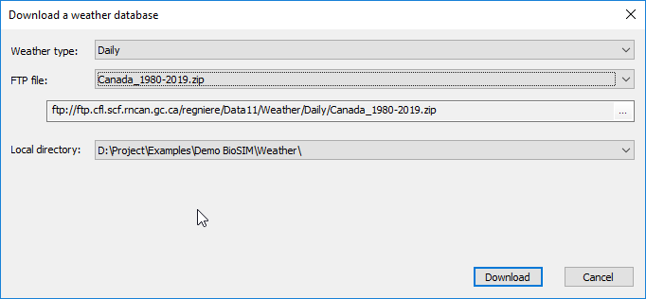By default, BioSIM will save the new database into the local “weather” sub-directory of the project. User that want to use the same database for different project can save database into a common weather directory define in BioSIM’ option.

Your final screen should look like the following image.

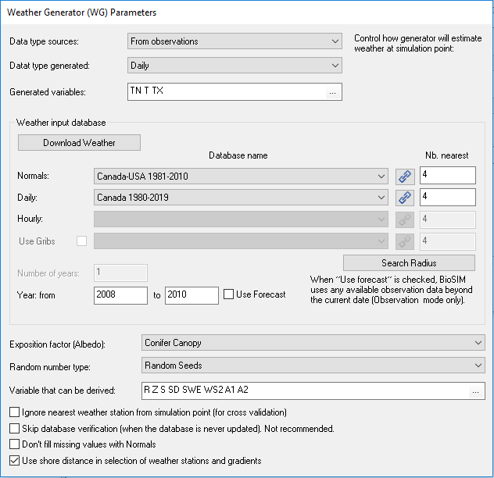NOTE: When the database you want to use is not available in the drop-down list, you must click on the Link a New File button Link_A_Database_button and indicate to BioSIM where the database is.

By default, this database (Canada 1980-2019.DailyDB) is installed in the \Weather\ sub-directory after using the download weather function.

Afterwards, type 2008 and 2010 in the **First year** and **Last year** fields, respectively.

NOTE: Even if you choose “From Observation”, a Normals database must be selected (in this case Canada-USA 1981-2010) to create weather gradient and to fill any gaps in the daily data

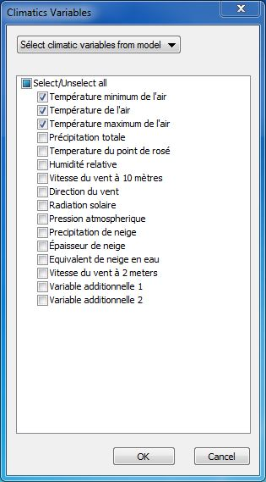You must choose the climate variables you want. In the generated variable field, click on «...» and select the model you want to simulate.

You will be using “DegreeDay (Annual)” in this example.

Leave all other fields to their default values and then click OK in the Weather Generator Input File Manager dialog to accept these new parameter values.

You can now take a closer look at the weather stations that have been matched to the locations you have specified for this simulation.

Because this weather generation is based on historical daily data (2008 to 2010), there is no need to replicate the runs which means that, in this case, the value in the **Replication** field of the Weather Generation Editor dialog can be left at 1.

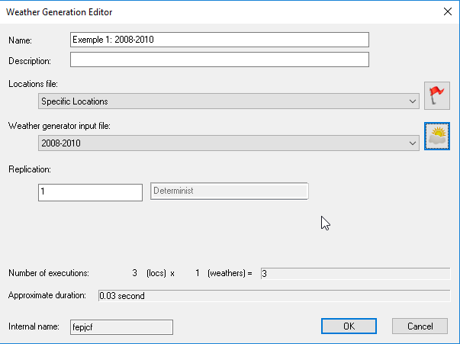NOTE: The greyed field to the right of the **Replication** field always displays whether the weather generation use disaggregation (stochastic) or not. Stochastic weather generation require replication.

In the Project window, select the weather generation “Example 1” and click the Show Matched Stations button  on the main toolbar, or select [Tools] and then [MatchStations…] from the menu bar. This will open the MatchStations application.

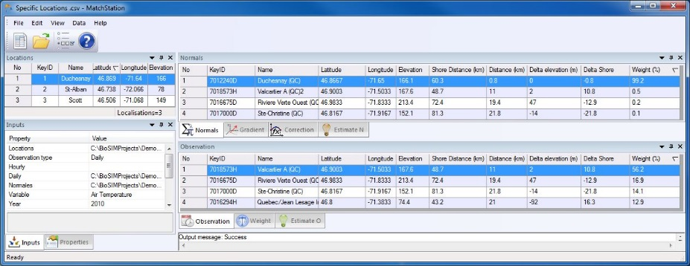

When a location is selected in the left hand side list field, all drop-down lists and other list fields of the dialog are updated with the information concerning this location.

In the «Inputs» window, you can select the type of data (daily, hourly), weather variable, number of neighbors and year.

The «Properties» window displays the coordinates and the elevation of the selected location.

The «Normals» window displays the information on the closest Normals stations matched to the selected location. While the «Observation» window displays the information on the closest Daily/Hourly stations matched to the selected location. Please note that for a given location, Normals and observation stations matched may differ.

Both the Normals and Observation station list fields contain a column that displays the weight (%) each weather station has in generating weather data for the selected location (assuming there are no missing data). These weights are proportional to the virtual distance from the location. Virtual distance includes elevation and shore distance.

The Weight panel show a graphic of the real weight of each time step (hours,days) taking into account the missing values.

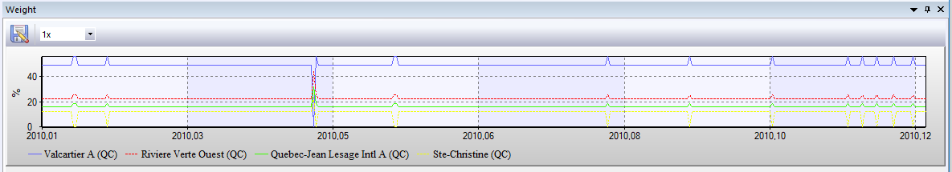

Along with the distance, elevation and shore distance columns can be useful in identifying errors in the specification of locations (e.g. positive longitude in the western hemisphere).

If you double-click on a weather station in the observation panel, the Hourly/Daily Editor will open.

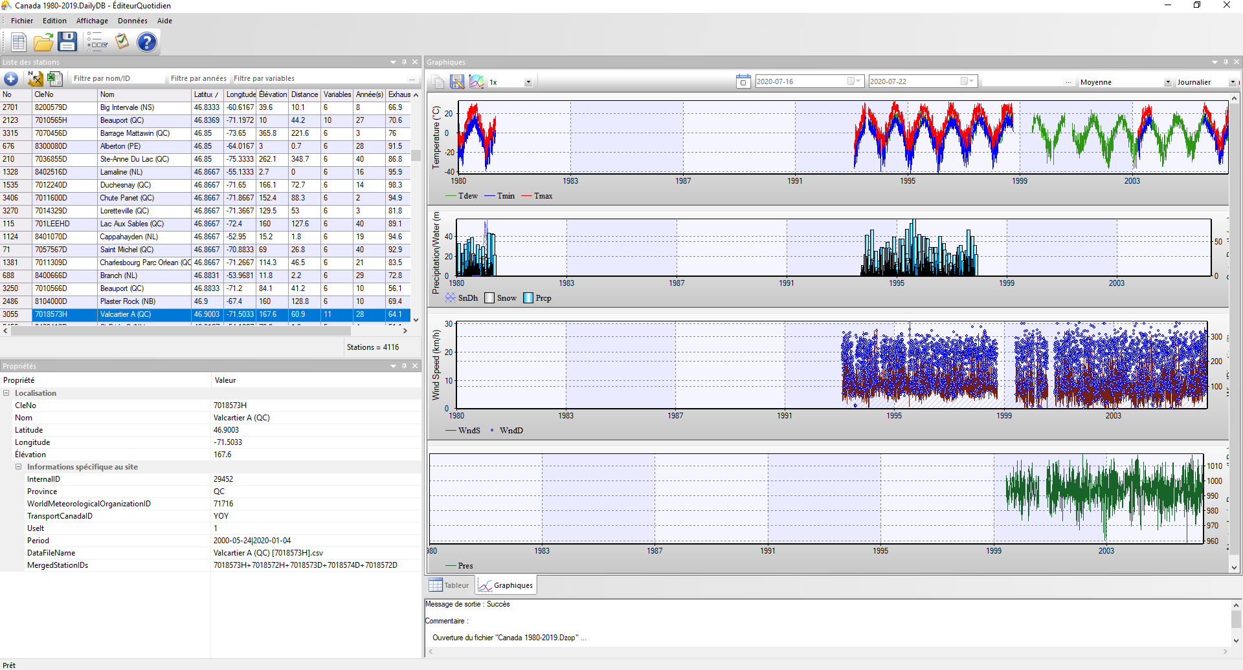

See the HourlyEditor/DailyEditor manual for more information.

## Step 3: Defining Model Execution

Select a weather generation (in this case, Example 1: 2008-2010) to which you want to add an Model Execution and click the Add Model Execution button  in the first row of the Project window’s toolbar, or select [Project] and then [Add Model Execution …] from the menu bar.

This will open the Model Execution Editor dialog, which a new model execution can be defined or an existing model execution can be edited.

Type Degreeday in the **Name** field, this name will appear in the Project window.

If you wish, you can type in a description of the simulation being defined in the **Description** field. This description will appear in the Execute Message Log window once the component has been executed.

Select the model you want to simulate. You will be using “DegreeDay (Annual)” in this example.

Click the Define Model Input button  located at the far right of the **Model input** field. Two dialogs will appear; the first dialog is the Model Input File manager and the second is a model specific dialog (in this case “DegreeDay (Annual)”) which varies with the model selected.

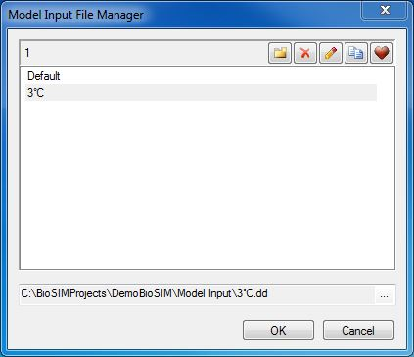

The number of model input (s).

The full path of the file

Click the New button New_button_icon in the Model Input File Manager dialog and type in 3°C as the name of the new set of parameter values to be defined. A new file with the name 3°C.dd will be created in the \Model Input\ sub-directory of the project.

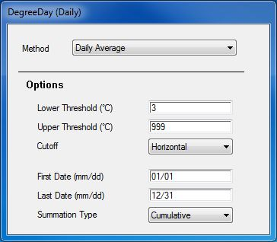

To edit the parameters of this new file, select it in the Model Input Editor dialog list field. For this example, type 3 in the **Degree-day threshold** field of the DegreeDay (Daily) dialog and then click OK in the Model Input File Manager dialog to save your new parameters.

Because the “DegreeDay (Annual)” model is deterministic, there is no need to replicate the runs which means that, in this case, the value in the **Replication** field can be left at 1.

NOTE: The greyed field to the right of the **Replication** field always displays whether a model is stochastic or deterministic. Stochastic models usually require replication.

## Step 4: Defining an analysis to interpret the results

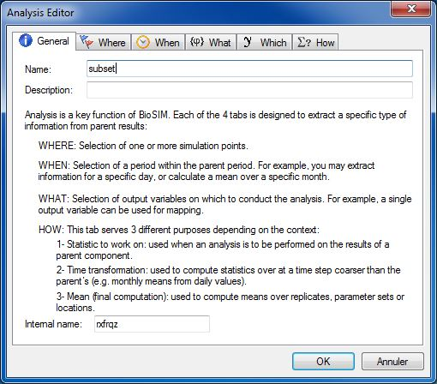Select a component (in this case, *Exemple 1: 2008-2010*) to which you want to add an analysis and click the Add Analysis button  in the first row of the Project window’s toolbar, or select [Project] and then [Add Analysis…] from the menu bar.

This will open the Analysis Editor dialog which is composed of 6 tabs: *General*, *Where*, *When*, *What, Which* and *How*. For a complete description of each tab, please refer to the manual

In the *General* tab, type Subset in the **Name** field, this will be the name of your analysis (in the Project window).

You may also enter a useful description of the analysis to be performed (in the **Description** field) which you will be able to see in the Execute Message Log window.

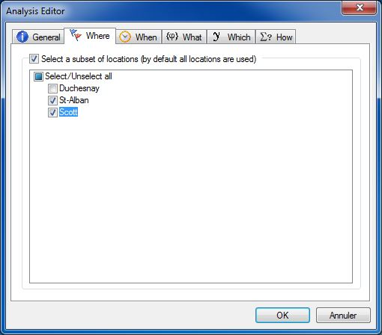In the *Where* tab, check Check_button the “Select a subset of locations” checkbox, this will open your location list and allow you to select one or more locations.

For this example, check Check_button the St-Alban and Scott locations.

In the *When* tab, check Check_button the “Select a period” checkbox and type 2008/04/01 in the **Beginning** field and 2009/08/31 in the **End** field.

Since the “Example 1” simulation covers the years 2008 to 2010, this will limit the period covered by the “Subset” analysis from April 1st 2008 to August 31st 2009.

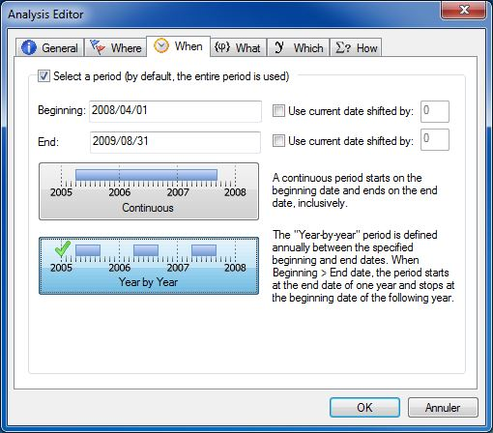By default, the *When* tab is set for coverage of a “Continuous” time period using boundaries defined by the beginning and end dates entered in the appropriate fields. As a result, data from the entire period covered between the beginning and end dates are used by BioSIM to compute a single value.

Click the Year by Year button Year_by_Year_button. This will make BioSIM use data from the period covered between the beginning and end dates on a year by year basis. Thus, it will use the April 1st to August 31st periods for 2008 and 2009. Data outside the specified dates, year by year, will be disregarded during computation.

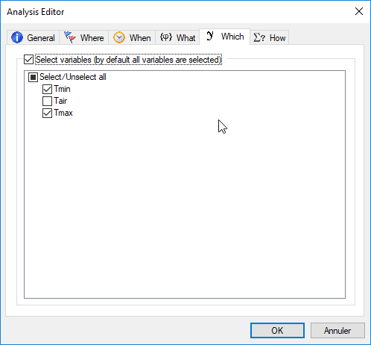In the *Which* tab, check Check_button the “Select variables” checkbox and select the checkboxes of the variables you are interested in.

For this example, check Check_button Tmin and Tmax.

In the *How* tab, check Check_button the “Define time transformation” checkbox.

Then, select “Monthly” from the right hand side

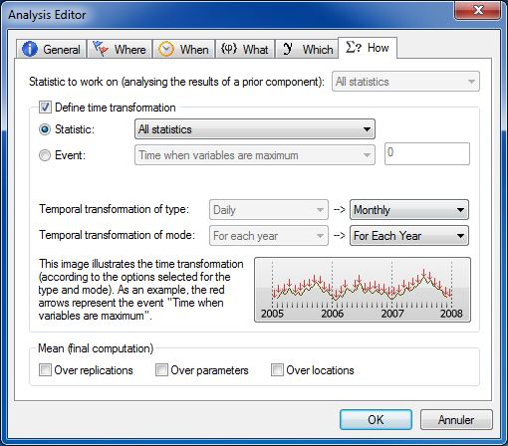drop-down list of the **Temporal transformation of type** field and “For each year” from the right hand side drop-down list of the **Temporal transformation of mode** field.

Make sure that the default “Statistic” radio button RadioButton_button is selected and that the drop-down list on the right is set to “All statistics”.

Uncheck Uncheck_button the “Over replications” checkbox and then click OK to save the specifications entered for all tabs.

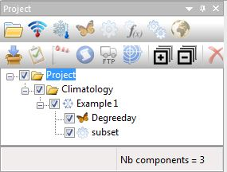Before running the weather generation and the analysis, make sure that the simulation “Example 1” and the analysis “Subset” checkboxes are checked Check_button in the Project window. Then, click the Execute Checked button  on the main window’s toolbar, or select [Project] and then [Execute Checked] from the menu bar.

The BioSIM progress bar will briefly appear before the results become visible in the *Spreadsheet* window.

Please note that when the Execute Checked button  is clicked, results are created/updated for all checked components of the project.

**To view the results:**

Select the “Subset” analysis in the Project window. The numerical results for this analysis can be viewed in the *Spreadsheet* window.

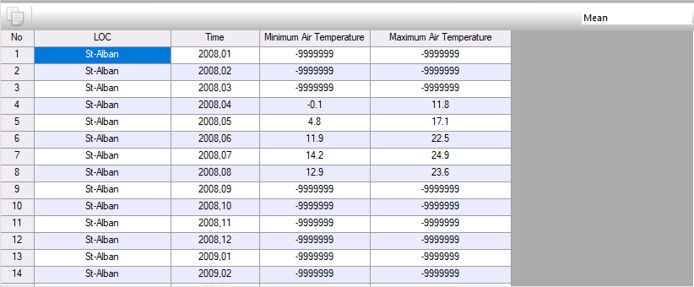

BioSIM always shows the child component’s results in the temporal format (all years) of the parent component. Therefore, missing values (-999) are used to fill the cells that were outside the desired period for the child component

The drop-down list you see in the upper right corner of the spreadsheet window allows you to choose the statistic for which you want to view the current results.

For example, if you select “Nb Values”, you will be able to see how many values were used to calculate the statistics.

## Step 5: Adding a component onto another component

In the Project window, select the “Subset” analysis and add a new analysis to it by clicking the Add Analysis button. This will open the Analysis Editor dialog.

In the *General* tab, type Mean of temperature in the **Name** field.

For this example, there is no need to modify anything in the *Where, When,* *what and which* tabs.

In the *How* tab, select “*Mean*” from the drop-down list to the right of the **Statistic to work on** field. This will instruct BioSIM to use the mean among the results of the parent analysis.

Check Check_button the “Define time transformation” checkbox to activate the right hand side drop-down lists of the **Temporal transformation of type** and **Temporal transformation of mode** fields and select “Annual” and “For each year” respectively.

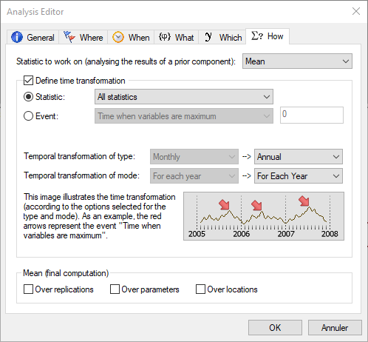

Make sure that the default “Statistic” radio button RadioButton_button is selected and that the drop-down list on the right is set to “All statistics”.

UncheckUncheck_button the “Over replications” checkbox and then click OK to save the specifications entered for all tabs.

Before running this new analysis**,** uncheck Uncheck_button all component because they have already been executed and it is not necessary to run them again.

To select only the component you are interested in executing, hold down CTRL and check Uncheck_button the component checkboxes (next to the component in the Project window). Make sure that the new analysis “mean” checkbox is checked Check_button and then click the Execute Checked button  on the main window’s toolbar, or select [Project] and then [Execute Checked] from the menu bar.

The BioSIM progress bar will appear briefly.

**Understanding these new results:**

The main window’s *Data* tab for this new analysis to be the Air Temperature (April to August) per year for each location.

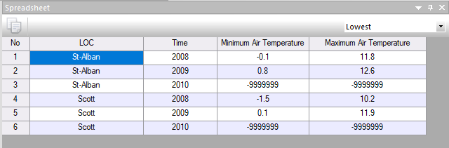

To see the lowest or highest monthly mean values, select *Lowest* or *Highest* in the drop-down list.

## Step 6: Exporting the results

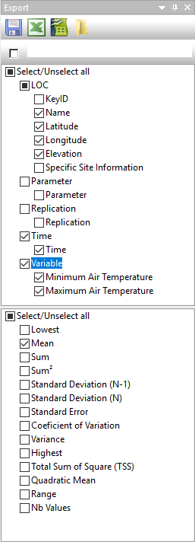To export the results of your analysis, select the columns you want to export in the upper list field of the Export window; in this example, check Check_button Name, Latitude, Longitude, Time and Minimum and Maximum Air Temperature. You must also select the statistics you want to export from the scroll down menu in the lower list field of the Export window; in this case, choose Mean.

The To Spreadsheet button  allows you to export the results as a CSV file in the \Output\ sub-directory and simultaneously open it in the spreadsheet of your choice (e.g. Excel or LibreOffice).

Send the results of the current component outside To Calc (spreadsheet for LibreOffice)

Try sending this export to your spreadsheet software now.

If BioSIM is unable to find the spreadsheet software on your computer, a dialog will appear allowing you to browse and indicate to BioSIM where to find it.

NOTE: If you do not specify a name in the **File name** field of the Export window by default, BioSIM will assign the component’s name to the export file, in this case, “Export (Mean).csv”.

The export check beside the export name let to automatically export the result at the project execution.

# 3 Example 2

The objective of the second example is to show you how to extract an event from a Phenology model.

## Step 1: Defining a new group of components

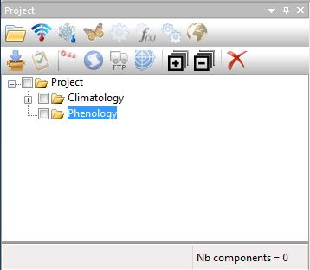

**Reminder:** To add a component into another, select the parent component and then, click the appropriate button in the toolbar’s first row to add a child component to it.

In this second example, we will skip over certain steps explained earlier. If you do not remember how to proceed, please refer to the previous example.

Select the main group called “Project” in the Project window and add a new group to it (). Rename this group Phenology.

## Step 2: Defining a new simulation

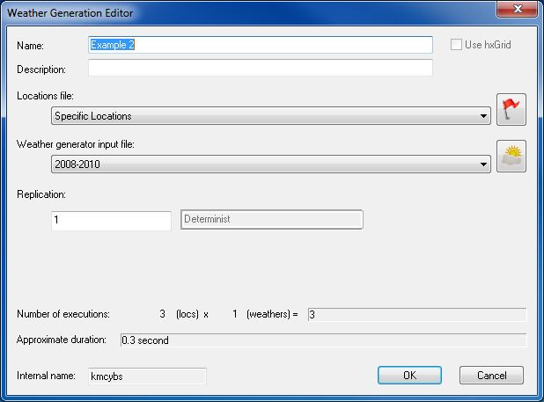Select the “Phenology” group you just created and add a Weather Generation ().

This will open the Weather Generation Editor dialog with which a new Weather Generation can be defined.

Type Example 2 in the **Name** field, this name will appear in the Project window. Because you have already defined a WG Input parameter set in the previous example (2008-2010), you can now select it directly in the drop-down list next to the Weather generator field and use it in this example.

Select “Specific Locations” from the drop-down list next to the Location list field (also defined in the previous example).

NOTE: if a modification is made to the input parameters of a model, a weather generator or a location list set, all simulations using these sets will use the new set of parameters at the next execution. Therefore, if you want to keep your original input parameters for a given simulation, you must create a new set of input parameters for each new simulation.

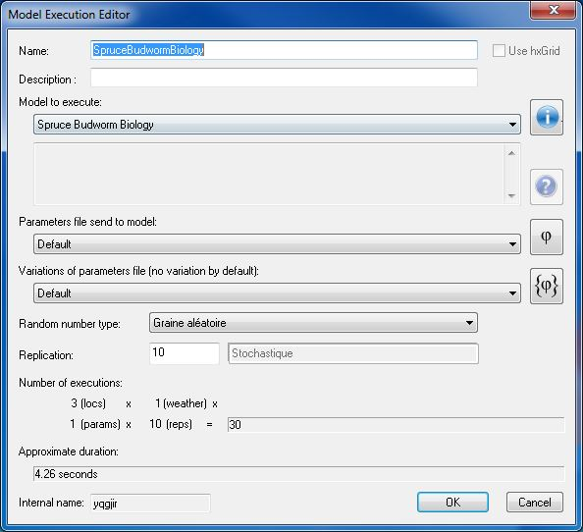Select a weather generation (in this case, Example 2) to which you want to add an model and a Model Execution ().

In the Model Execution Editor dialog, type Spruce Budworm Biology in the Name field and select “Spruce Budworm Biology” from the drop-down list next to the Model field. This is the simulation model you will be using in this example.

You will be using the default values for the parameters of the “Spruce Budworm Biology” model; therefore, the Model field’s drop-down list can be left on “Default”.

Although this simulation is based on historical daily data (2008-2010), because the “Spruce Budworm Biology” model is stochastic, you need to replicate the runs. Type 10 in the Replication field.

This completes the specifications of the new simulation. Click OK to save the current settings and return to the main BioSIM window.

## Step 3: Defining an average output analysis

Select a “Spruce Budworm Biology” Model Execution and add an analysis to it ().

In the *General* tab of the Analysis Editor dialog, type Average Output in the **Name** field, leave all other tabs (*Where*, *When*, *What, Which* and *How*) on their default parameters and click OK to save your new analysis.

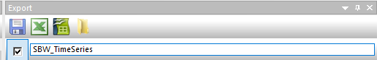In order to automatically export outputs, enter the file name under the Export region of the page. Select the box next to it once you have entered the file name.

NOTE: An average output analysis is used to compute means over replications.

## Step 4: Defining and running an event extraction analysis

Select the “Spruce Budworm Biology” Model Execution again and add another analysis to it ().

In the *General* tab of the Analysis Editor dialog, type Date of Peaks in the **Name** field.

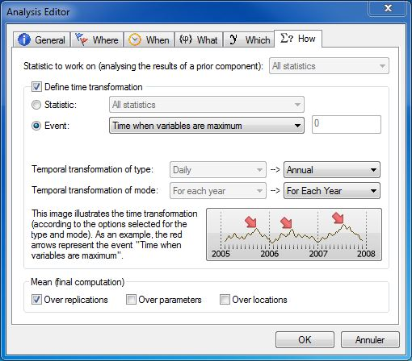Leave the *Where*, *When, What* tabs to their default settings.

In the *Which* tab, check Check_button the “Select variables” checkbox and then, check Check_button L3, L4, L5 and L6.

In the *How* tab, define the event to be extracted from the results of the parent component (the Example 2 simulation).

NOTE: The greyed left hand side drop-down lists of the **Temporal transformation of type** and **Temporal transformation of mode** fields display the output time format of the parent component.

Check Check_button the “Define time transformation” checkbox and select the “Event” radio button. This will activate the drop-down list and allow you to select the event type you want to analyse.

For this analysis, you want BioSIM to determine the day when the variables (i.e., frequencies of 3rd, 4th, 5th and 6th instars) are at their maximum which means you need to select “Time when variables are maximum” from the drop-down list.

## Step 5: Running the checked components

Before running this new analysis**,** make sure that the “Climatology” group and all of its components are unchecked Uncheck_button because they have already been executed and it is not necessary to run them again. Then, Execute () your project for a second time (all “Phenology” group components).

You will see the BioSIM progress bar briefly before the results appear in the *Data* tab of the main window.

NOTE: The current number of checked components is always displayed in the bottom right corner of the Project window (Nb runs =).

**Interpreting the results:**

1- “Date of Peaks” analysis:

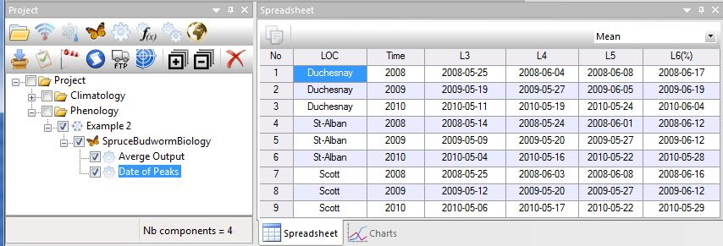

The results represent the dates when each larval stage should be at its maximum for each year at each location.

NOTE: Make sure that the statistic you are looking at is “Mean”.

You can modify the date format in the *Region* page of the Options dialog (see the manual for details)

2- “Average Output” analysis:

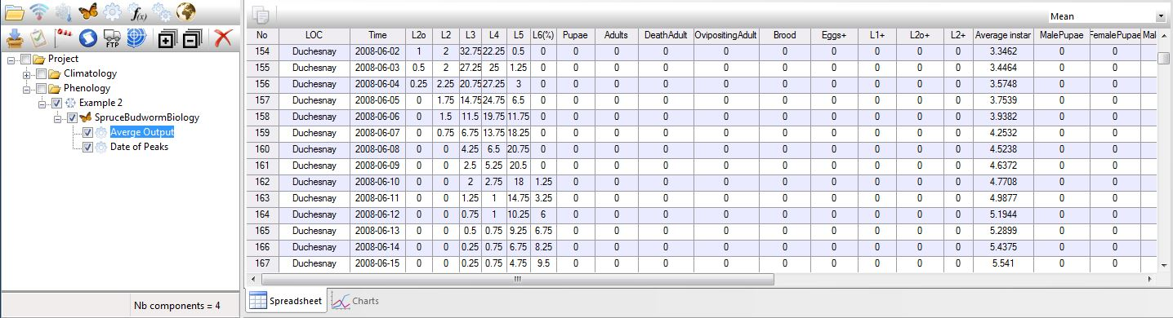

The results represent the average of the 10 replications for the frequency of each larval stage for each day of each year for all locations.

## Step 6: For R user: add automatic execution of R script

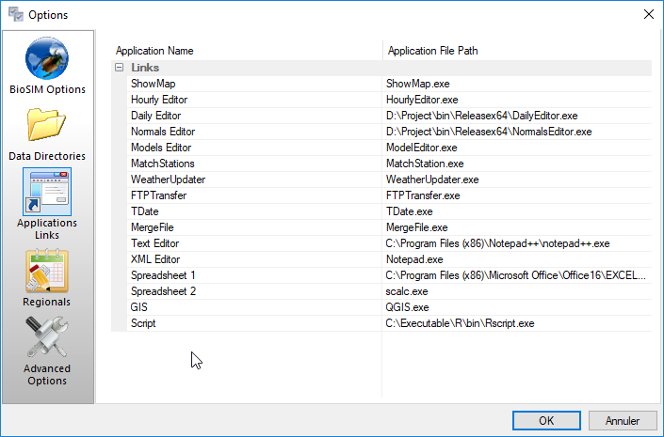

To use R, begin by setting the R path. Click on the options button  and go down to the Applications Link. Two columns will appear, “Application Name” and “Application File Path”. In the file path next to Script, enter the path to Rscript.exe in the bin sub directory of the R installation directory. Click OK to save.

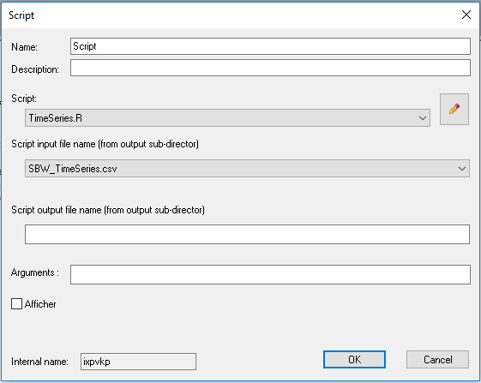Next select the analysis “Average Output”, and click on the R script button  to add an execution of a script. A script pop-up will appear, with two drop-down lists. One is to enter the script and the other is for the script input file name (output of BioSIM in the Output sub-director”).

For the input file name select or type “SBW\_TimeSeries.csv”.

For Script, click on edit  button and enter “TimeSeries.R”. BioSIM will create a skeleton of R script and open it into a text editor.

Copy the following script at the end of the file:

***#use only the first year of the first location***

***Esim <- Esim[ Esim[,1]==unique(Esim[,1])[1]&Esim[,2]==unique(Esim[,2])[1],]***

***Esim$Date <- paste(Esim$Year,formatC(Esim$Month, width=2, flag="0"),formatC(Esim$Day, width=2, flag="0"), sep="-")***

***Esim$date <- as.POSIXct(Esim$Date)***

***#select variable to plot***

***variables <- c("L2","L3","L4","L5","L6","Pupae","Adults");***

***Resolution=300***

***png(file=GetFilePath("../Images/TimeSeries.png"), height=11, width=8.5, units = "in", res = Resolution, pointsize = 10)***

***# bott,left,top,righ***

***par(mfcol=c(1,1), mar=c(2.5, 4, 3, 1), oma = c(0, 0, 0, 0), font.main=1, cex.main = 1.5, cex=2, cex.lab=1.2)***

***yLim = range(Esim[,variables])***

***test1<-Esim[,variables]>0.01***

***test2 <- apply(test1, 1, function(x) {any(x)})***

***xLim = range(Esim[test2,]$date)***

***color <- rainbow(length(variables)+1, alpha=0.75)***

***plot(NA, type="n", las=TRUE, xlim=xLim, ylim=yLim, xlab="", ylab="", frame=FALSE , xaxt = "n" )***

***dates\_pos <- seq(min(xLim), max(xLim), by="weeks")***

***axis(1, dates\_pos, format(dates\_pos, "%b %d"), cex.axis = 1.0)***

***for(v in c(1:length(variables)))***

***{***

***lines(Esim[,variables[v]]~Esim$date, col=color[v],lwd=5, lty = (v-1)%%3+1)***

***}***

***legend('topright', legend=c(variables), lty=(c(1:length(variables))-1)%%3+1, lwd=5, col=color, bty = "n", cex=1.25, seg.len=3)***

***mtext("SBW stage [%]", 2,cex=3, line=2.5)***

***mtext(paste("SBW stage,",unique(Esim[,1]), unique(Esim[,2])), 3, cex=3, line=1)***

***# Turn off device driver (to flush output to image)***

***dev.off()***

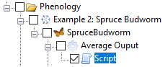Select only the script component and execute. Normally, if all works correctly, a new image will be created in the images sub-directory of the project.

The following graphic will be available

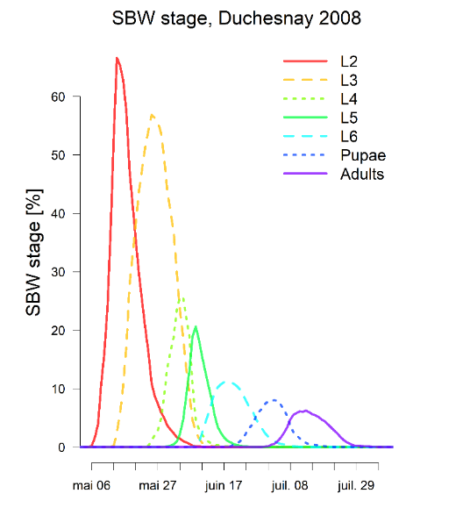

# 4 Example 3: Mapping

## Step 1: Defining a Weather Execution and Model Execution

In the Project window, select the “Climatology” group and a Weather Generation(). Leave the **Weather generator** **Input** fields’ drop-down lists on “Default” (the weather generator will use the Canada-USA 1981-2010 Normals database as default).

Click the Define Location List button () on the right hand side of the **Locations File** field in the Weather Generation Editor dialog.

Then, click the New button New_button_icon in the Location File Manager dialog and type in Random Locations as the name of your new location list. A new file with the name Random Locations.csv will be created in the \Loc\ sub-directory of the project.

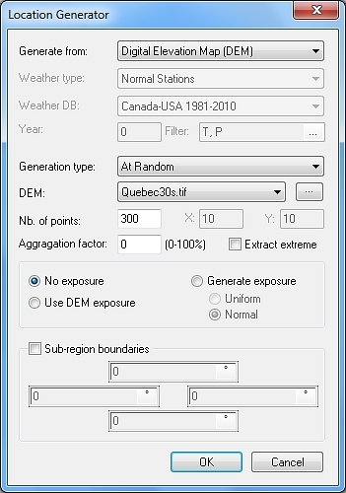In the Location List Editor dialog, click the Generate button  to open the Location Generator dialog which can generate points from weather stations or DEM’s.

In this dialog, select “Digital Elevation Map (DEM)” in the drop-down list of the **Generate from** field and “At Random” in the drop-down list of the **Generation type** field.

In the **DEM** field’s drop-down list, select “Quebec30s.tif” (this DEM of Quebec comes with the demo). “Quebec30s.tif” DEM can be find in the BioSIM demo MapInput sub-directory. If you execute the demo from scratch, copy this file into the MapInput sub-directory of your current project.

NOTE: If you want to use a different DEM you can link it to BioSIM with the browse button  to the right of the **DEM** field’s drop-down list. This will open the Linked Data Editor dialog at the *Input Maps* tab where you can link a new map by clicking on the Link New File button .

In the **Nb. of points** field, type 300 and click OK. Please refer to the manual for guidelines concerning the minimum number of points required.

The BioSIM progress bar will briefly appear. This will generate a list of 300 random locations (and their elevations) from the input DEM Quebec30s.tif. Click OK in the Location File Manager dialog to save your new “Random Locations” list.

Because these simulations are based on Normals (as defined earlier by selecting “Default” in the **Weather generator** field of the Simulation Editor dialog) weather will be stochastic. Thus, you need to replicate the runs. As an adequate amount of replications, type 10 in the **Replication** field of the Simulation Editor dialog. Please refer to the manual for guidelines concerning the minimum number of replications required.

Select a weather generation « Example 3» to which you want to add an Model and click the Add Model Execution button  in the first row of the Project window’s toolbar, or select [Project] and then [Add Model Execution …] from the menu bar.

In the Model Execution Editor dialog, type DegreeDay in the **Name** field and select “DegreeDay(Annual)” from the **Model** field’s drop-down list (this is the model that you will be using in this example).

You have now defined all your simulation parameters, click OK to save the current settings and return to the main BioSIM window.

## Step 2: Defining a subset analysis

Select the Model “DegreeDay” and add an Analysis to it ().

In the *General* tab of the Analysis Editor dialog, type Average in the **Name** field and click OK to save these parameters (leave all other tabs on their default parameters).

## Step 3: Defining a mapping

Select the analysis “Average” you just created and click the Add Mapping button  in the first row of the Project window’s toolbar or select [Project] and then [Add Mapping…] from the menu bar. This will open the Mapping dialog.

The **Nb of maps created** field (greyed) shows the final number of maps that will be created from the parent component (the “Average” analysis). In this case, 1 maps will be created: 1 replication X 1 variables X 1 year X 1 parameter set.

In the **Name** field, type Ex 3.

The **Description** field allows you to enter a useful description of the mapping to be performed.

Select “Universal Kriging” from the drop-down list next to the **Interpolation method** field.

Select “Quebec30s.tif” (same map from which your random locations list was extracted) from the drop-down list next to the **Input DEM** field.

BioSIM uses an automatic scheme based on time (%t), parameter (%p), component (%c) and variable (%v) references to name output maps with minimal need for user input. The user can choose the information and specify the format used to name output maps. In the **Output map name** field, keep “%c%v”, delete %t and add parentheses around the %v then, click OK.

Because you chose to keep “%c(%v)” in the **Output map name** field, the name of the output map file will include the component name followed by the name of the variable in parenthesis (e.g. Ex 3(DegreeDay).tif ).

Since the temporal dimension of the parent component of this mapping example is 1, and no parameter variation was used, you do not have to specify the temporal reference (%t) or the parameter reference (%p) in the output map name.

## Step 4: Execute All

Uncheck Uncheck_button all Project components except the current weather generation (Example 3), Model Execution(DegreeDay), analysis (Average) and mapping (EX 3) then, Execute () your project a third time.

The BioSIM progress bar will appear in the Job in Progress dialog and allow you to see the progress of the various simulation tasks (a total of 300 locations x 10 replicates = 3000 model runs).

Afterwards, BioSIM will execute the analysis, optimise the Kriging parameters and create the output map(s). Please note that this can take several hours, depending on the number of model runs, the size of the map, and the machine being used.

The results will be shown in the *Data* tab of the main window.

## Step 5: Viewing the R² cross-validation results

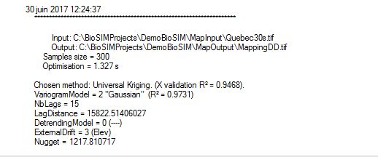You can see the cross-validation results (R² values: goodness of fit between model output and the map) of the spatial interpolation (Universal Kriging) in the Execute Message Log window.

In this example the cross-validation R² for mapping DegreeDay was 0.9468, very high.

## cid:image007.png@01D6554D.3288D7C0Step 6: Viewing the maps

User can use ArcMap or QGIS (a free open source software0 to directly show BioSIM’ output maps.

QGIS can be downloa from : [https://www.qgis.org](https://www.qgis.org/fr/site/forusers/download.html)

Make sure to select the appropriate download for the device being used.

Once downloaded and installed, select the map to be viewed, in this case “Ex3(DD).tif”. Right-click and select “Open Output Map Directory”.

From the Output Map Directory, drag the georeferenced image into QGIS.

The map will now appear in QGIS, as seen in the image below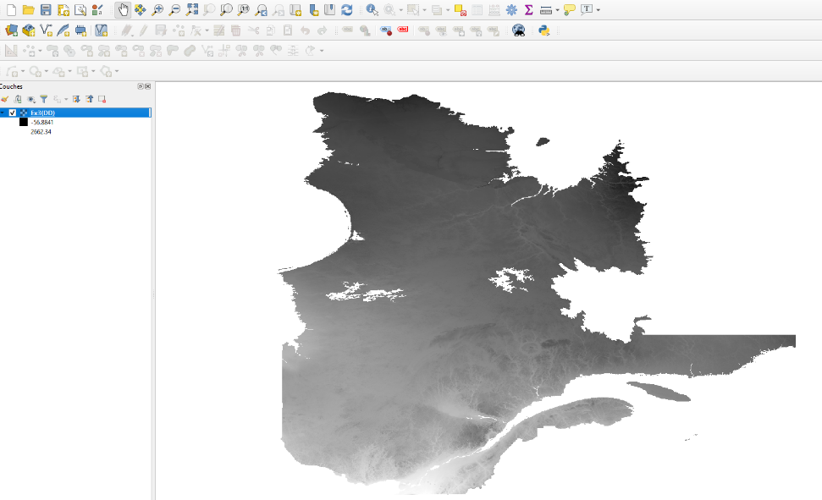.

# 5 Example 4: Update current daily database

## Step 1: Adding a new Subgroup of components

In the Project window, select the “Phenology” folder icon and then add Group () and rename it Example 4: Hemlock Looper.

## Step 2: Defining an Update weather data

Select the “Example 4: Hemlock looper” group you just created and click the Add Update weather data button  on the first row of the Project window’s toolbar, or select [Project] and then [Add Update weather…] from the menu bar.

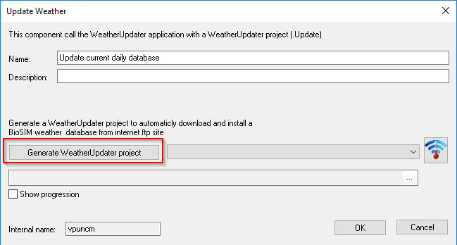This will open the Update Weather dialog with which a new WeatherUpdater project can be defined.

Type Update current daily database in the **Name** field and click Generate WeatherUpdater project. The Generate WeatherUpdater project dialog will appear, with tree drop down menus: “Weather type” and “FTP file” and “Local Diretory” and one editbox.

Select Daily as the Weather type, and then choose “Canada\_2019-2020.zip” as the FTP file.

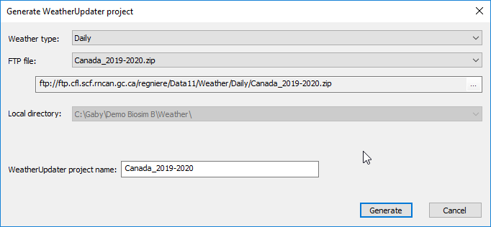

The local directory specifies where the file will be saved. When selecting the FTP file, a project name will be automatically created under Weather Updater project name.

NOTE: The FTP file depends on the year in which the reader completes this tutorial. Use the appropriate database.

Click on Generate to Generate a new WeatherUpdater project.

The WeatherUpdater icon  next to the drop-down list can be clicked to open the created project into the WeatherUpdater application in order to view parameters.

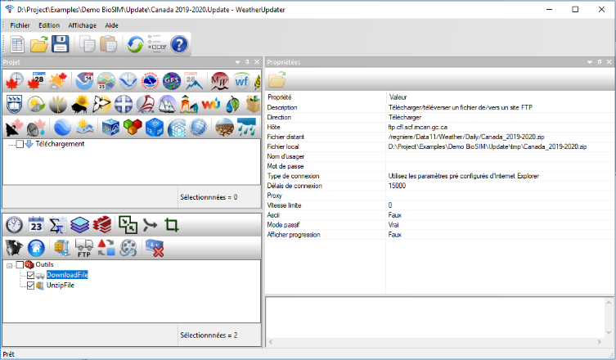

In the Update Weather dialog, select “Canada 2019-2020.Update” from the drop-down list next to the Project list field and click Ok to create the new component.

It’s important here to understand that the Updater Weather component in BioSIM will only call the WeatherUpdater application with a WeatherUpdater project. This let the possibility to automatically update the weather before updating all others components.

## Step 3: Defining a weather generation and model execution

Select the “Example 4: Hemlock looper” group and add a weather generator named "Current Weather" as in the preceding examples.

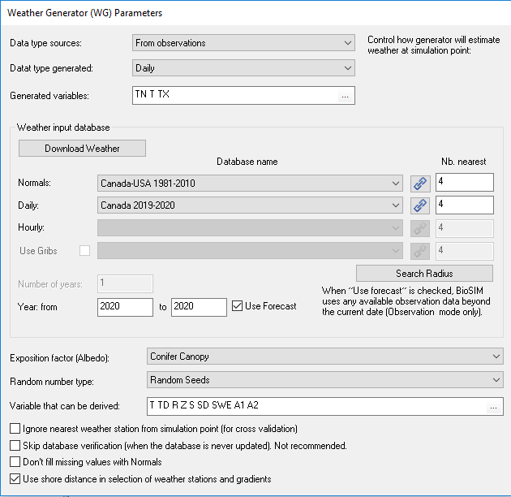

In the localization file we will create a new one, as in example 3, we will name "Newfoundland". Generate random locations list with 300 points from Newfoundland DEM. Newfoundland DEM can be find in the BioSIM demo MapInput sub-directory. If you execute the demo from scratch, copy this file into the MapInput sub-directory of your current project.

Click the Define WG Input button  to define a new weather regime assembly parameters. In the Weather Generator Input File Manager dialog, click the New button New_button_icon and type in Current as the name.

You choose “From observations” in the data type Sources.

In weather input database choose “Canada 2019-2020” (or appropriate years) in the Daily, and use current year. Keep default all other parameters and click OK to save.

NOTE: In order to see “Canada 2019-2020” as an option in the Daily drop-down list, the Weather Updater must have been executed. Alternatively, select the Download Weather option in the Weather Generator and then select “Canada\_2019-2020.zip”. This should now appear in the Daily drop-down list.

Because the end of the actual year is stochastic, we have to define replications. Type 10 in Replication and click OK to save.

Select a weather generation (Current weather) and click the Add Model Execution button.

Type HemlockLooper in the **Name** field, this name will appear in the Project window.

Select the model you want to simulate. You will be using “HemlockLooper” model in this example.

Leave all others parameters in default and click OK to save.

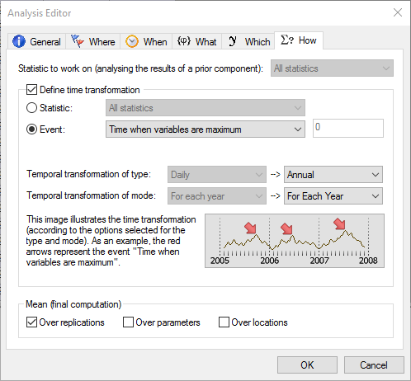

## Step 4: Defining an output analysis

As in the previous examples add an analysis.

In the *General* tab of the Analysis Editor dialog, type Analysis in the **Name** field.

Leave the *Where*, *When, What* tabs to their default settings.

In the *Which* tab, check Check_button the “Select variables” checkbox and then, check Check_button L3, L4 and Pupae.

In the *How* tab, check Check_button the “Define time transformation” checkbox and select the “Event” radio button. Select “Time when variables are maximum” from the drop-down list and click OK to save.

## Step 5: Defining a function Analysis

Select an analysis (in this case, Analysis) to which you want to add a function analysis and click the Add Model function analysis button.

Type JDay in the **Name** field, this name will appear in the Project window.

Double-click the available variables to move them to Equation.

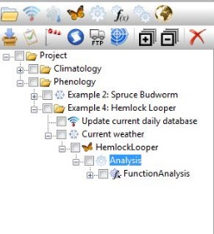For each variable add JDay in the equation and change temporal type to Atemporal (JDay function convert date normal to Julian day number, click Help button for more function and detail).

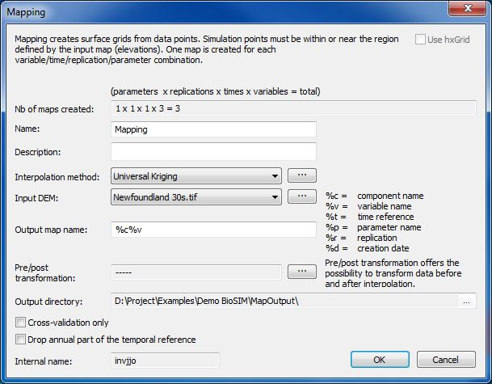

## Step 6: Defining a mapping

In this step we will follow the same procedure as in example 3 step 3, select “Universal Kriging” as Interpolation method and select the Input DEM “Newfoundlamd 30S.tif”.

## Step 7: Execute and Viewing the maps

Uncheck Uncheck_button all Project components except the current example components and Execute () your project.

The results will be shown in the *Data* tab of the main window.

As in the example 3, drag the map into QGIS to visualise it.

## Step 8: Adding event (date) mapping

Select Peak analysis component and Add Mapping. The total number of maps created will be three (1 parameter x 1 replication x 1 times x 3 variables). Enter “Date Mapping” for the **Name,** this will be displayed in the project window. From the drop-down menus select “Universal Kriging” for the Interpolation Method and “Newfoundland 30s.tif” for the Input DEM. In the section for Output Map Name, enter “%v\_%t(date)”. Click OK.

Click on Create a legend file. Select Create QGIS style file. The two drop-down menus give options for Palette and Color. Select RdBu and Interpolated, respectively. Finally, enter Use mean as +/-1.5 and click OK to save.

Execute only the last map creation.

## Viewing the maps

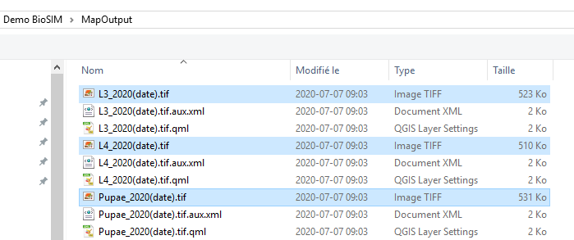

In QGIS, Click on add layer  and select Raster . The new created files can now be selected. Click Add to open it into QGIS.

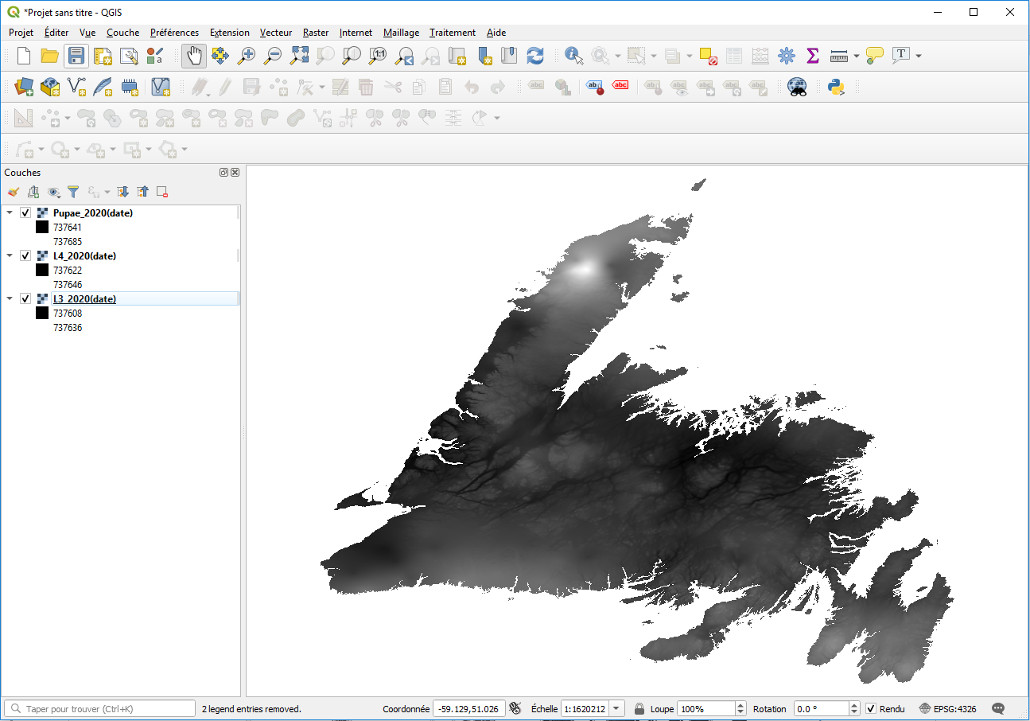

For each raster, select layer, right-click on it and select Properties.

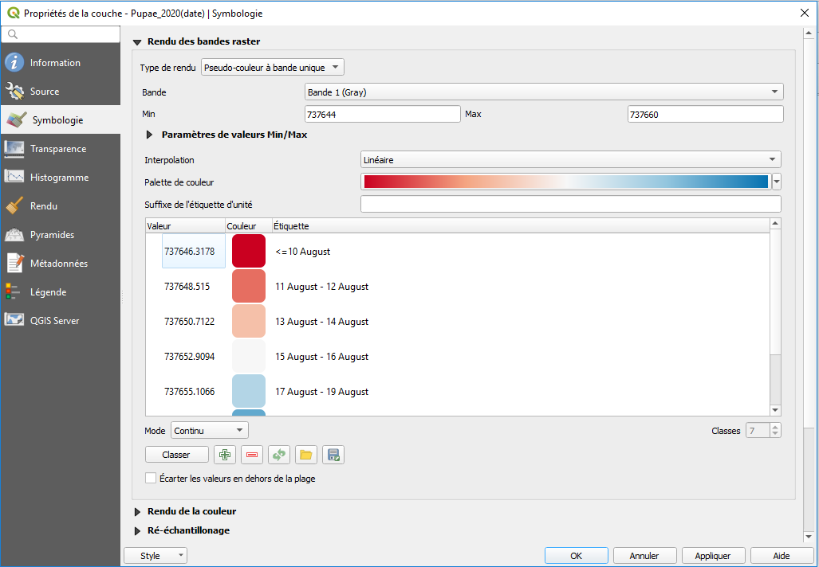Click on the drop-down list labelled as Style, and select Load Style. Select the .qml file (created by BioSIM into the MapOutput sub-directory of the project) associate to each raster. This will load the good legend dates.

After loading the .qml file, click OK.

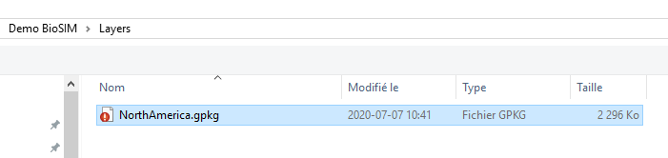Then select the add vector layer button  (this can also be done by selecting Layer at the top of the screen, holding the mouse over Add Layer, and then selecting Add Vector Layer). At the top of the dialogue is a space for File Name. Select the North 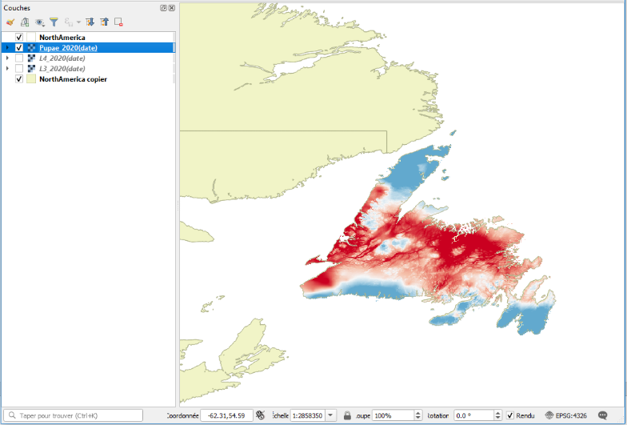America package from the layer sub-directory of the demo and click Add.

To select the pattern that fills the North America layer, double-click on the layer and select Symbology. Choose “Land” and click OK.

Check the boxes next to the layers of interest. In our case, we will check NorthAmerica, Pupae\_2020(date), and NorthAmerica copy. Your final map should resemble the image here.

## Export a map as image

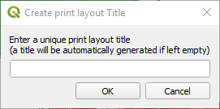To export the map as an image, select Project and then New Print Layout. You will be prompted to enter a title for this layout (leaving it blank will result in an automatically generated title).

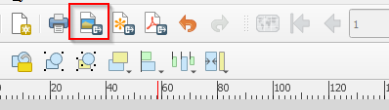A new window will open with a series of functions. Click on the Add map button . Using your cursor, select the area of the page where you would like to place your map by holding down a point and then dragging to the desired size. Next you will click on the Add Legend button . Again, using your cursor select the area of the page where you would like to place the legend.

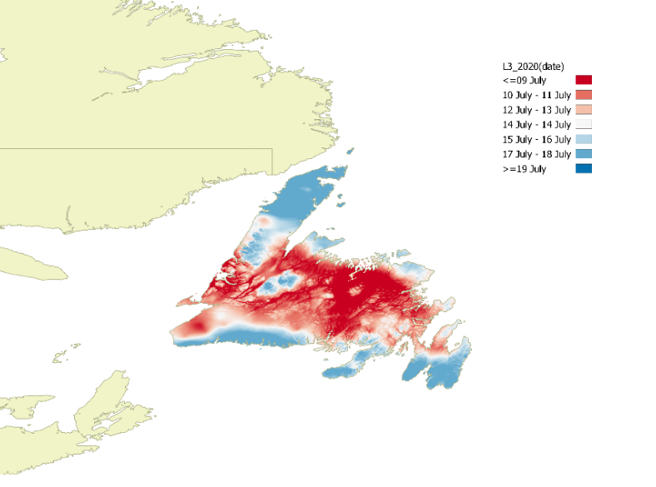

Once satisfied with the layout of your map, you can export it as a PNG by selecting the Export as Image button.

Other sources of layers can also be downloaded from the GADM site. This allows you to use detailed country, states, and county layers.

<https://biogeo.ucdavis.edu/data/gadm3.6/gpkg/gadm36_CAN_gpkg.zip>

The natural earth data site allows you to download layers for oceans, lakes, and rivers. <https://www.naturalearthdata.com/http//www.naturalearthdata.com/download/10m/physical/10m_physical.zip>

<https://www.naturalearthdata.com/http//www.naturalearthdata.com/download/10m/cultural/10m_cultural.zip>